City of Atkins April 2020
Bruce Visser, Mayor Council meetings 1st & 3rd Monday @ 7:00 pm @ City Hall
City Council: Joey Svejda, Lana Robison, Heather Rinderknecht, Nathan Shepard & Robert Spading
City Hall: 319-446-7870 M-F 7:30-12 & 1-4 Library: 319-446-7676 M-F 10am-12pm & 1-6 Sat. 9am-12pm
Check out www.cityofatkins.org NOW ACCEPTING CREDIT CARD AND ONLINE PAYMENTS!!!!!!
Hello from the Mayor's office!
Meet the Mayor will be canceled until further notice.
Regards, Bruce Visser, Mayor

Atkins City Wide Garage Sales
Canceled Annual Easter Egg Hunt

We Offer Credit Cards!
CD Rates
CD Interest Rates
Term | Interest Rate | Annual %
7-179 Days | 0.50 | 0.50
6 Month | 0.50 | 0.50
12 Month | 1.00 | 1.00
3 Month = 91 Days 6 Months = 182 Days
Adjust-A-Rate CD
18 Month | 1.15 | 1.15
24 Month | 1.25 | 1.25
36 Month | 1.35 | 1.35
60 Month | 1.50 | 1.51
IRA Variable Rates
1 Year | 2.30% | 2.32%
Effective March 17, 2020

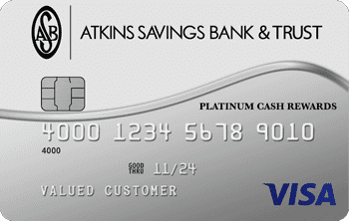
Interest rates are subject to change without notice.
Minimum Deposit for all terms is $1,000.00
Penalty for early withdrawal.

Live Your Own Journey.
With Atkins Savings Bank & Trust
Visa® Platinum Cash Rewards Card
Earn up to 3% cash back on qualified purchases…
Visit our website to apply today!

Atkins Savings Bank & Trust
97 Main Ave PO Box 46 Atkins, IA 52206
(319) 446-7700 * www.atkinssavingsbank.com

