City of Atkins December 2019
Bruce Visser, Mayor Council meetings 1st & 3rd Monday @ 7:30 pm @ City Hall
City Council: Joey Svejda, Tim Harbach, Heather Rinderknecht, Rodney Haerther, & Robert Spading

City Hall: 319-446-7870 M-F 7:30-12 & 1-4 Library: 319-446-7676 M-F 10am-12pm & 1-6 Sat. 9am-12pm
Check out www.cityofatkins.org NOW ACCEPTING CREDIT CARD AND ONLINE PAYMENTS!!!!!!
Hello from the Mayor's office!
City Hall and Atkins Public Library will be Closed on December 25th in observance of Christmas. They will also Closed on January 1st, 2020 for New Year’s Day. Meet the Mayor will be at Atkins City Hall on December 7th between 9am and 10am.
Regards, Bruce Visser, Mayor
Atkins Public Works

Please do not blow your snow onto City Streets or Alley’s. Please direct your snow to the sides of your driveway or side yards.
Atkins Public Library
The Holidays Silent Auction was a huge success!
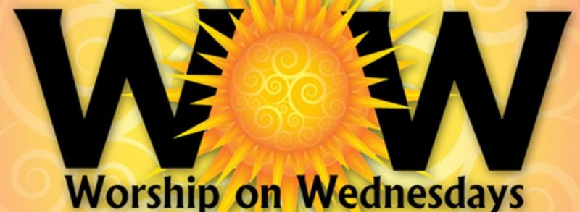
This event raised $1,170.00 to Help Helping Hands Food Pantry. A huge Thank you to all to donated and helped with this event. Thank you to all who came and joined the fun!
Atkins Pleasant Hill Presbyterian Church
Worship on Wednesday
Calling all 1st through 7th graders. Worship on Wednesday is worship service just for you! December 4th, 18th from 6:30 to 7:30pm.
Atkins Women’s Club Holiday Tour of Homes!
The Atkins Women’s Club will be hosting their 11th Annual Holiday Tour of Homes on Sunday, December 8th! The time is 3pm to 6pm. Tickers are available at each house. A ticket is only $7 this year, and it will have a map of the homes on it. There are 3 homes. More information coming look at the Women’s Club Facebook or CityofAtkins.org for updated information!
Mike and Jennie Palumbo - 401 First Street
Marty and Rachel Kruse – 623 High Point Drive
Shawn and Jade Nutt – 634 Prairie Hill Drive
Atkins Pleasant Hill Presbyterian Church
There will be having a potluck and cookie exchange on Dec 8th, 2019 at 10:30am
Atkins Community Club
Annual Christmas Party

Atkins Community Club will have their annual Christmas Party at the legion on Saturday, December 14 with the Billy K. Murray Band starting at 11:45am and Santa’s visit and raffle at 12:30pm. Make sure your name is in the raffle by 12:30. We hope to see you there!

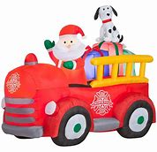
The 38 Fire Truck and Santa will be visiting Atkins on Sunday, December 15. Santa and his helpers will be starting on the west side of town around 4pm. Please have your outside lights on so Santa will know where to stop. If your lights are on all the time, have your front door open, if it has a screen door of course, for another indicator that there are children home. Or the always popular way is to have the kids waiting by the window or the door so Santa can see them.

Happy Holidays
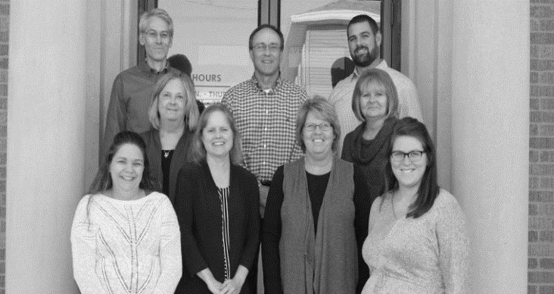

Join us Friday December 20th for our
Holiday Open House
8:00 am – 6:00 pm
Atkins Savings Bank & Insurance
97 Main Ave Atkins, IA 52206
(319) 446-7700 * www.atkinssavingsbank.com

Serving Coffee, Cider, & Cookies
Tuesday December 24th 8 – 12pm
Wednesday December 25th – Closed
Tuesday December 31st 8 – 12pm
Wednesday January 1st - Closed
December Hours

