City of Atkins June 2019
Bruce Visser, Mayor Council meetings 1st & 3rd Monday @ 7:30 pm @ City Hall
City Council: Joey Svejda, Tim Harbach, Heather Rinderknecht, Rodney Haerther, & Robert Spading

City Hall: 319-446-7870 M-F 7:30-12 & 1-4 Library: 319-446-7676 M-F 10am-12pm & 1-6 Sat. 9am-12pm
Check out www.cityofatkins.org
NOW ACCEPTING CREDIT CARD AND ONLINE PAYMENTS!!!!!!
**************************************************************************************************
Hello from the Mayor's office!
The Mayor will be at City Hall June 8 and June 22, 2019 from 9am to 10am. Stop by if you have questions.
City Hall receives calls occasionally about the Street Lights being out or malfunctioning in some way. Alliant Energy, the City Electrical Service suppler, conducts the maintenance on streetlights. The City pays to operate each light with a monthly service bill. So, if you see a streetlight out, you can call Alliant Directly 24/7 (1-800-255-4268), or visit their website at AlliantEnergy.com, search for Street light, and you will see a form to report the outage. Complete the form and you will get a response directly to you when the street light repair will be completed. That way you are in the know first hand!

Thank a volunteer! Atkins Community runs on volunteers. Fire Department, boards, commissions, civic groups, church groups, scouts, youth sports, all run on volunteers. When you see one of the many helpers at an event it is likely a volunteer. Thank them for their time and effort, they are what make things happen! The groups depend on donations too, so if you appreciate their work, send a donation to them, it is always appreciated. Regards, Bruce Visser, Mayor
Summer Reading will start June 5th, 2:30pm to 3:30pm. This is for grades preschool – 3rd. The program will end on June 26th. Our summer theme is outer space so come join us for some action packed out of this world fun! New policy at the library: Only ten items can be checked out per household. Fines must be paid before you will be allowed to check out more materials. This is due to the large number of overdues and lost items.
Atkins Citywide Cleanup Days
Atkins City residents only – City reserves the right to refuse any item
Saturday June 22nd, 2019 8am to 2pm
North End of Northview Avenue
The following is a partial list of items accepted free of charge:
Furniture, mattress & box springs, etc Bicycles (tires must be removed)
Lawn mowers (tires, gasoline and oil must be removed)
BBQ Grills (gas grills must have tank removed) Batteries of any kind
Items accepted with a Disposal Fee: (cash or check – Payable to City of Atkins – no credit cards)
Computer Monitors (flat screen/LCD) - $5.00 LCD/Flat Screen TV’s - $5.00
CRT/Tube Television or Monitors - $5.00 For 22” & Smaller; $10.00 for 23” or larger
Large Appliances: $5.00 Small LP Gas Tanks 20 lb size and smaller- $5.00
Desktop printers/copiers - $5.00 Large Printers/copiers - $10.00
Small Appliances (Microwaves) - $5.00
These Items will not be Accepted:
Appliances Filled with Food Large Propane Tanks Tires Household recycling items
Household Garbage Yard- Waste Building Materials Construction materials of any kind
Hazardous Waste (gasoline, oil, oil filters, paints, solvents etc.)

If you need to get rid of a working refrigerator, freezer, or air conditioner, Call Alliant Energy at 1-866-255-4268 for information on their recycling program. Contact Atkins City Hall if you have questions at 319-446-7870

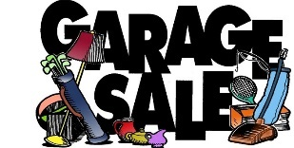
Atkins City Garage Sales are going to be June 8th, 2019. You can advertise your sale by going to The Atkins Medical Clinic. The Advertisement is $3.00. Atkins Presbyterian Church will be serving lunch from 10:30 to 1 pm during garage sales.

Get your produce and crafts ready to join us for the 2nd Annual Atkins Farmers Market! Dates for the Market are June 2, 16, July 7, 21, August 4, 18 and Sept. 15th from 5-7pm. In June the Market will be held at the soccer field. The remaining season will be back at the park. We still have a few spots for music at the Market. So, if you have a talent and would like to perform...please let us know! This year we are looking for organizations/clubs to volunteer for the kids’ corner. For more information please text/call Pamela 319-981-7755. Get ready to join us for a fun family filled season at the Market!
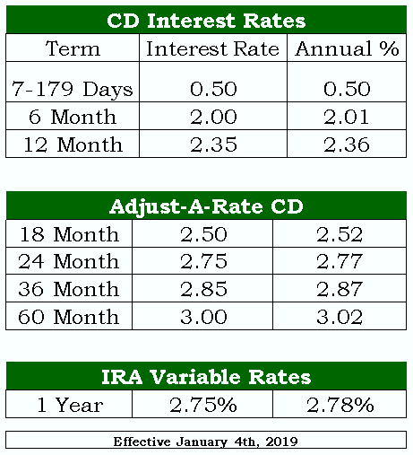
Atkins Savings Bank & Trust
97 Main Ave PO Box 176 Atkins, IA 52206
(319) 446-7700 * www.atkinssavingsbank.com
Hours:
Monday – Thursday 8am -3pm
Friday 8am – 6pm
Appointments Available Upon Request

Interest rates are subject to change without notice.
Minimum Deposit for all terms is $1,000.00
Penalty for early withdrawal

Our four scholarship winners are: Cameron Eggert, Nathan Ettleman, Maya Sahu and Nathan Simpson. They were handed the scholarships during Awards Day on May 8th. Congratulations! 🤗👏🤗👏🤗

The Atkins Community Club will be hosting the 2019 Watermelon Days. Save the dates of Friday, August 2nd and Saturday, August 3rd. We would truly appreciate your help on Saturday with some of the games. One hour of your time would make a world of difference for us.
Below is the Sign Up Genius link that you will use to sign up to volunteer.
There are two sign ups.
1. https://www.signupgenius.com/go/10C0C4DABA72EA2FB6-20191
H & H Fun Rides/Inflatables: (Need to be 18 years old or older)
2. https://www.signupgenius.com/go/10C0C4DABA72EA2FB6-2019
Three Kids Rides—Remember, that any student who is looking for volunteer hours can sign up for the kids rides. Check us out on The Atkins Community Club Facebook.

I just wanted to send a reminder that the less water we send into our wastewater system the better. Sump pumps and down spouts going into the sanitary sewer system are not allowed and makes the sanitary system more expensive to run. If you have this, please divert the water to the outside of your home. If you are not sure please call us at 319-446-7870 and we can look at it with you and answer any questions.
Thank you, Todd Damon, Atkins Public Works

