Atkins Watermelon Days

Hosted by Atkins Community Club

August 3rd & 4th 2018 Schedule of Events

Friday
5:00 pm Helping Hands Concessions
6:00 Youth Bean Bag Toss Tournament
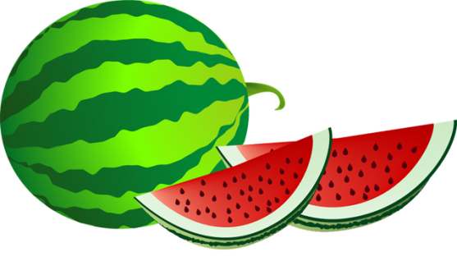
Snow Cones (until 8:00 pm)
6:30 5K Run and Run/Walk
7:00 Kiddie Parade
6:00 – 8:00 Kids Games and Rides
6:00 – 8:30 Bingo (Food Tent)
7:30 Kids Free Mini-Mini Bale Toss
8:45 Movie Night - “CoCo”

Saturday

9:00 – 3:00 Gordy Nelson Memorial Car Show (Registration 8:00 – 12:00)
10:00 Parade (new parade route – see attached)
11:00 Beer Tent – open until midnight
11:00 – 5:00 Kids Games and Rides
Benton Band Boosters Dunk Tank and Snow Cones
11:00 – 7:00 St. Stephens Food Concessions
11:45 Presentation of Colors – Atkins American Legion Post #217 (Basketball Court)
12:00 Billy K Murray Band (Gazebo)
12:00 – 4:00 Bingo in Air-Conditioned City Hall
1:00 Adult Bean Bag Toss Tournament (Beer Tent)
2:00 Watermelon Eating & Seed Spitting Contests (Basketball Court)
2:30 – 5:30 Band “Music by Scott and Annette” (Library Stage)
3:00 Watermelon Bowling (Basketball Court)
4:00 Balloon Toss (Basketball Court)
6:00 Atkins Has Talent (Library Stage)
6:00 Cow Pie Bingo (Basketball Court)
7:00 Post Prom Concessions (Beer Tent)
8:00 – 12:00 Band “Two Buck Chuck” (Library Stage)
Dusk FIREWORKS – winners will be announced before the fireworks

*Check out our Facebook page and the City of Atkins website for more information.*

FRIDAY events
Concessions
5:00 pm
Grilled Pork Loins & Hot Dogs
Chips, Popcorn, Funnel Cakes, Cotton Candy and Drinks
Sponsored by Helping Hands Food Pantry

Mini – Mini Bale Toss
7:30 pm
Ages 1 – 5 and 6 – 10 divisions
Sponsored by 4-H Fremont Go Getters

Kids Games, Rides and a Movie
Kids Games and Rides 6:00 – 8:00 pm
Bloomsbury Farm Barrel Train
Movie 8:45 – “CoCo”

Early Bird Tickets available for Saturday Games and Rides.
$20.00 Wristbands sold Saturday only!
Kiddie Parade
7:00 pm
5th Grade and under join us to the music of “Watermelon Crawl”
Decorate your bike, wagon, stroller, yourself or dress up for fun!
Line up at 6:45 at Main Ave and 1st Street

5K Run & 1 Mile Walk/Run
6:30 pm at Park Pavilion – Pick up packets at 5:30 pm
Proceeds support Benton Community Cross Country Team
Registration form on our Facebook page
Youth Bean Bag Toss Tournament

6:00 pm
$5.00 per team
15 years and younger – 2 person teams
Teams Register by 5:45 pm
At the Atkins City Park
