City of Atkins March 2017
Kevin Korsmo, Mayor Council meetings 1st & 3rd Monday @ 7:30 pm @ City Hall
City Council: Diane Herman, Tim Harbach, Nathan Shepard, Rodney Haerther, & Frank King
***************************************************************
Amber Bell, City Clerk Todd Damon, Dir. Public Works Cathy Becker, Librarian
DaShawn Wilson, Deputy Clerk Jarrod Tomlinson, Public Works Vicky Myers, Assistant
319-446-7870 319-446-7676
Mon-Fri 7:30-12 & 1pm -4pm 319-446-7870 Mon-Fri 10-12 & 1-6 Sat 9-12
*********************************************************************************************
Nice weather is also bringing out more of our four-legged friends so remember that all animals must be on a leash or confined to yard or property. It is unlawful, per Atkins City ordinance 55.08 ANNOYANCE OR DISTURBANCE for the owner
of a dog to allow or permit such dog to cause serious annoyance or disturbance to any person or persons by frequent and habitual howling, yelping, barking, or otherwise; or, by running after or chasing persons, bicycles, automobiles, other vehicles or other domestic animals.

Per Atkins City ordinance 55.09 SANITATION. It is the duty of every person owning or having custody or control of an animal to clean up, remove and dispose of the feces deposited by such animal upon public property, park property, public right-of- way or the property of another person.
Let’s all be courteous and mindful to our neighbors and our community when exercising our pets.
It’s almost that time of the year…. GOLF CART REGISTRATION!!!
Renewal form and golf cart ordinance can be found online or can be picked up at city hall. Fee of $25.00 and proof of insurance should be submitted by March 15, 2017.
Permit numbers not assigned by April 1st will be given away to next paid registrar

Atkins Helping Hands Pantry would like to THANK YOU for the great turn out for the Valentine’s Dinner.
The proceeds are well appreciated and will help our continued effort in helping families in our community. -Dave Duball

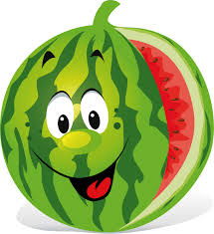
Challenge Your Watermelon Artistic Skills!
T-Shirt Design for Watermelon Days
Watermelon Days – August 4-5, 2017

Design: Watermelon theme. All drawings must be done on an 8.5 x 11 sheet of paper. You can use up to six colors: You can use markers, colors or colored pencils. You may also do your design on the computer and submit a disc along with a paper copy of the design. A catchy logo also helps!
In the design you need to have the date and Atkins Watermelon Days.
You need to sign your design and include your phone number. If under age 18, we need to have a parent give permission to use your design if chosen.

Ages: All ages!

Prize: If your design is chosen, you will receive a free t-shirt and $25.00!
You may choose to have your name on front.

Deadline: All designs must be submitted before April 25, 2017 to the Atkins Public Library.

Questions: Contact Cathy Becker at the public library. #446-7676

The Atkins Community Club members will choose the design.
New to the library: DVDs – Miss Peregrines Home for Peculiar Children, Trolls, The Girl On The Train, Sully, Around the Clubhouse World

CDs – The Sleepwalker-Bohjalian, Havana Storm-Cussler, Right Behind you-Gardner
Adult Fiction – The Bookshop On the Corner-Colgan, Levi's Will-Cramer, The River At Night- Ferencik, Right Behind You-Gardner, River Road-Coodman, The Kitchen House-Grissom, Glory Over Everthing-Grissom, Glory Over Everything-Grissom, The Dry-Harper, Whiskey Rebellion-Hart, Whiskey Sour-Hart, Whiskey For Breakfast-Hart, Whiskey You're The Devil-Hart, Whiskey Tango Foxtrot-Hart, Burn-Hardt, Measure of Darkness-Jordan, Heartbreak Hotel-Kellerman, Alaska Nights-Mcomber, A Deadly Affection-Overholt, Never Never-Patterson, What Matters Most-Rice, The Second Mrs. Hockaday-Rivers, Closer Than You Think-Rose, Alone in the Dark-Rose, Every Dark Corner-Rose, Idaho-Ruskovich, Lucky boy-Sekaran, Almost a Bride-Watson
Summer Reading Program: We are looking for volunteers both adult and junior to help with the Summer Reading Program. Please call the Library at 446-7676 if you are interested.

Teen Advisory Board – Meeting on Wednesday, March 15, 2017 - 1:00 pm. Teens interested in being a member of the board please call the Library at 446-7676.

Spring Break Movie – Wednesday, March 15, 2017 - 2:00 – 4:00 pm at the Library. Movie to be determined. School age children are invited to watch a movie and bring an individual snack to enjoy during the movie.

Children's – Last Stop on Market Street-de la Pena, Pete the Cat and The Missing Cupcakes-Dean, I'll Hug You More-Duksta, The Cow Said Meow-Himmelman, If You Ever Want To Bring An Alligator To School, Don't-Parsley, Mighty, Mighty Construction site-Rinker, Blackout-Rocco, Dragons Love Tacos-Rubin, Heart to Heart-Shannon, The Deliverance of Dancing Bear-Stanley, How to Catch The Easter Bunny-Wallace

Junior Fiction – The Girl Who Drank the Moon-Barnhill, The Boardwalk-Coleman, Love and Fear-Coleman, Minecraft Restone handbook-Farwell, Minecraft Combat handbook-Milton, Minecraft Essential handbook-Milton, Minecraft Construction handbook-Needler, Story Thieves-Riley, The Stolen Chapters-Riley, Secret Origins-Riley

Young Adult – The Iron trial-Black, Frostblood-Blake, The Copper Gauntlet-Black, The Bronze Key-Black, Scarlet-Meyer, Cress-Meyer, Fairest-Meyer, Fairest-Meyer, Winter-Meyer, Carve the Mark-Roth, Scythe-Shusterman, The Young World-Weitz, The New Order-Weitz, and The Revival-Weitz

The Book Club read “The Kitchen House” by Kathleen Grissom and have recommended it as their favorite pick of all the books they have read. Book club meets 2nd Monday of each month at 2:00 pm in the Atkins Library.
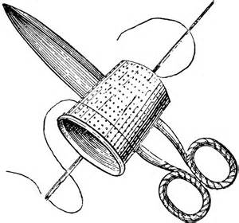
The Bookshop on the Corner by Colgan will be our feature book of the month.

Quilting Class – If you are interested in making a t-shirt quilt please contact the Library at 446-7676 and leave your name and phone number. You must have your own sewing machine, rotary cutter, mat and basic sewing supplies.

____________________________________________________________________________________________
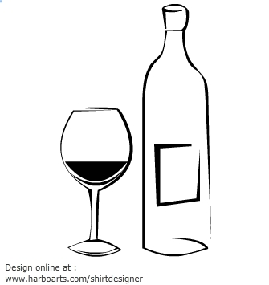
Remember not to miss the event this weekend!!
Saturday, March 4, 2017 at 7pm
3rd Annual
Raise a Glass for Atkins
Wine Tasting Live Dessert Auction Cash Bar
Admission: $25.00 per person
Casual Black & White Attire Suggested
For more information, Contact Atkins Library 319-446-7676 or Atkins Savings Bank 319-446-7700

