City of Atkins June 2017
Kevin Korsmo, Mayor Council meetings 1st & 3rd Monday @ 7:30 pm @ City Hall
City Council: Diane Herman, Tim Harbach, Nathan Shepard, Rodney Haerther, & Frank King

City Hall: 319-446-7870 M-F 7:30-12 & 1-4 Library: 319-446-7676 M-F 10am-noon & 1-6 Sat. 9am-12
All city information, forms, and contacts can be found online at www.cityofatkins.org
********************************************************************************************
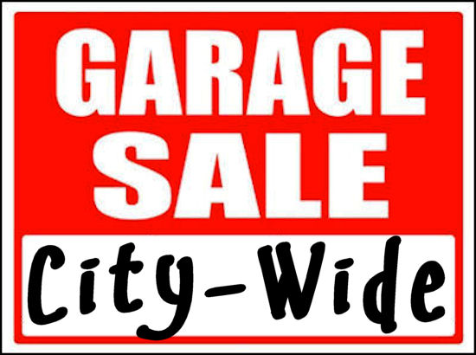
Atkins City Wide Garage Sale is THIS WEEKEND!
Saturday, June 10th
8am – 3pm
Maps can be found online @ www.cityofatkins.org

Lunch will be served at Atkins Presbyterian Church
121 Main Ave
10:30am – 1pm
Loose Meat Sandwiches, Hot Dogs, Potato Salad, Baked Beans, Chips, Drinks, & More

Do You like Ice Cream?????
Then be sure to join us for an ice cream social on Sunday June 11th from 3-5pm at the Atkins Soccer Park Pavilion. There will be FREE ice cream and activities for the kids!
Sponsored by AIM
“AIMing For A Better Atkins”

Reminder Sewer Debt Increase effective July 1, 2017.
An additional $15.00 will be added to July water bills.
Sewer debt fee will now be $30.00
Payment option of ACH is available. Forms can be found online or at City Hall.

Golf Cart Registration Reminder…. per City of Atkins Ordinance #179 “persons who wish to operate golf carts as a mode of transportation within the City of Atkins” must be registered. Registration form can be found online at www.cityofatkins.org or can be completed at City Hall. If you have a previously registered cart not in use please call 319-446-7870 to be removed from list.
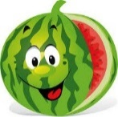
Watermelon Days is August 4-5, 2017. We need your help to make this annual event another success! Please think about volunteering especially the kids that need volunteer hours for school. This is a time that they can get as many hours as they would like. Adults, we can always use your help too!
Take pride in your community! Meet new people and catch up with old friends when you volunteer. If you don’t want to do this alone, ask a friend to do this with you. The more the merrier! Contact Christy Damon #446-6022

Atkins Women’s Club 2017 Scholarship Winners
Briann Brown
Cameron Korsmo
Grace McGovern
Congratulations to the Watermelon Days T-shirt Design Winner….
Ruth Ann Less

I love rumors…I always find out amazing things about myself I never knew. ~Unknown
Library News

Summer Reading Program Children ages 4 - 10 are invited to attend the Summer Reading Program. The Reading Program will run each Wednesday beginning June 14 thru July 19 from 2:30-3:30. Please drop your child(ren) off at the library no earlier than 2:25 and pick up promptly at 3:30.

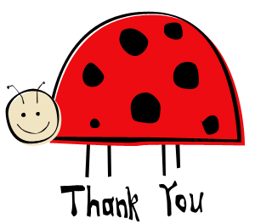
Thank you for your help! Thanks for the generous cash donations we have recently received from (8) patrons of the library. Your generosity helps make our Summer Reading Program successful! Your support means that each child will receive a new book to take home on the last day.

Thank You to the patrons that donated materials for the activities that the children will be doing during the Summer Reading Program.

Thanks to the patron that donated over 70 DVDs from his own collection to be shared with the Atkins residents.
Thanks to the following for contributing to the planters in front of the library & city hall:
Sara McLain & Cub Scout Troop #46

New in the library:
DVDs- Air Force One, All the Pretty Horses, The American President, Angels & Demons, As Good As It Gets, Batman Begins, Con Air, Comanche Moon, Crocodile Dundee, Crossfire Trail, The Dark Knight, Die Hard, E.T., A Few Good Men, Fireproof, Firewall, First Knight, Forrest Gump, The Fugitive, Geronimo an American Legend, Gran Torino, The Great Escape, Hidden Figures, Indiana Jones, Jaws, The Journey of Natty Gann, Jurassic Park, The Kingdom, LaLa land, Lost in Space, My Cousin Vinny, National Treasure, North to Alaska, Ocean’s Twelve, Oliver Twist, Open Range, Outbreak, The Pink Panther 2, Predator, Pride & Prejudice, Proof of Life, The Rainmaker, Risky Business, Robin Hood, Rumor Has It, Sam Elliot, Shooter, Spies Like Us, We Are Marshall. EASY – Rubble to the rescue! By Depken, Snail & Worm by Kugler, Meet Tracker! By Smith, Mission Paw by Sullivan. JUNIOR FICTION – Giant Trouble by Vernon. YOUNG FICTION – What Light by Asher, Song of Fire and Ice series by Martin, Mr. Monster by Wells, Young Inventors Guide series by Bowditch. ADULT FICTION - The Broken Road by Evans, The Book That Matters Most by Hood, The Thing About Love by James, No Easy Target by Johansen, The Fallen by Lusterbader, 16th Seduction by Patterson, The Scent of Rain and Lightning by Pickard, The Girl Who Knew Too Much by Quick, Startup by Shafrir, The Stars are Fire by Shreve, Against all Odds by Steel, The Things We Wish Were True by Whalen.

The New Soccer Pavilion Bathrooms are now open!!!!
Summer Hours: 7am to 9pm
Soccer Pavilion reservations are also being accepted for rental.
Contact Atkins Library at 319-446-7676 for rates & details
____________________________________________________________________________________________
Library Survey

Do you read the Library News in the monthly newsletter? YES NO
Do you visit the library? YES NO
Do you use the electronic library (Bridges/Overdrive)? YES NO
Do the current hours of operation serve your needs? YES NO
Do you use other libraries? YES NO
List others if YES: ______________________________________________________________________
Comments/Suggestions:________________________________________________________________________________________________________________________________________________________________________________________________________________________________________________________________
Return to library, book drop box, or water bill drop box. Thank you for your input.

