Council Meetings 1st & 3rd Mondays @ 7:30 pm at City Hall
City Of Atkins Newsletter - January 2017
City Council: Diane Herman, Tim Harbach, Nathan Shepard, Rodney Haerther & Frank King
www.cityofatkins.org
Kevin Korsmo, Mayor
Amber Bell, City Clerk
DaShawn Wilson, Deputy Clerk
319-446-7870
Monday-Friday 7:30-12pm & 1-4pm

Todd Damon, Director Public Works
Jarrod Tomlinson, Public Works
319-446-7870

Cathy Becker, Librarian
Vicky Myers, Assistant
319-446-7676
Monday –Friday 10-12pm & 1-6pm Saturday 9-12pm

Election Results: Kevin Korsmo was elected Mayor
Frank King was elected the City Council Seat

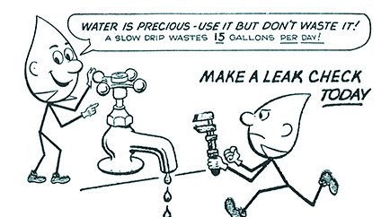
Water Bills: As of January 2017 there will be a $15 late Fee for any water bills received after the 15th of the month.

Reminder Notice: Water and Sewer rates will be increasing. A sewer debt fee of $15.00 will also be Effective in January 2017

ACC News:
The annual Atkins Community Club Christmas Party was held Saturday, December 10, 2016 at the Atkins Legion. We heard the wonderful music of the Billy K. Murray Band and Santa and Mrs. Claus were able to visit the children.
Children’s Grand Prize Winner: $50 Lizzy Wolf also coloring books from Atkins Pharmacy
Children’s Second Prize Winner: $25 – Aiden Svendsen also coloring books from Atkins Pharmacy
Adult Grand Prize Winner: $100 – Richard Schrombury
Adult Second Prize Winner: $50 – Tim Evans
Thank you for all the people that attended, Billy K. Murray Band, the decorators, the people that helped make the kiddie bags and anyone else that helped in any other way. A special thank you to our businesses that donated!
AIM News:
A HUGE THANK YOU to the people who have helped with the new restrooms at the Soccer Park:
Dean Haerther, Dan Novak and Dave Carte for donating their time and expertise.
Nick Taylor, Jeremy Franzen and Crew with Iowa Custom Construction & Insulation for donating the labor to put the roof on.
AND THANKS to everyone who supported our New Year's Eve Dance. Proceeds will be used to toward the restroom's interior and also benefit the Atkins Legion!
SAVE THE DATE!! Saturday Mach 4th 2017 – 3rd Annual Wine Tasting at the Atkins Legion Hall
Watch the February newsletter for important information!

Santa Tree

Atkins Savings Bank Staff wants to Thank everyone who donated gifts and food to the families in our community. We helped four families in our local community and the Presbyterian Church Food Bank. We know they greatly appreciated everything you all did for them!

THANK YOU!!

Atkins Savings Bank News:

Beginning January 1st a new business venture is opening in Atkins!
Atkins Savings Bank will be expanding its business into insurance. Ryan Gibney and Bob Paulsen are our insurance agents and will be opening their office in the basement of the bank. The agency is owned by Atkins Savings Bank. Ryan and Bob will be offering home, auto, business commercial, farm and crop insurance. Stop in and check out their new office and talk to Ryan or Bob and see how they can help you with your insurance needs! Phone # 319-446-7710

