City of Atkins August 2016 Newsletter

Watermelon Days Edition
August 5th & 6th
2016 Watermelon Days Event Schedule Inside!

David Becker, Mayor Council meetings 1st & 3rd Monday @ 7:30 pm @ City Hall
City Council: Diane Herman, Kevin Korsmo, Tim Harbach, Nathan Shepard, & Rodney Haerther

Atkins Contact information
Amber Bell, City Clerk Mike Jennings, Dir. Public Works Cathy Becker, Librarian
DaShawn Wilson, Deputy Clerk Todd Damon, Public Works Vicky Myers, Assistant
319-446-7870 319-446-7870 319-446-7676
Mon-Fri 7:30-12 & 1pm -4pm Mon-Fri 10-12 & 1-6 Sat 9-12

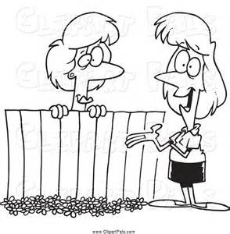
Did you know that you can find all the updated City of Atkins information on the website?
www.CityofAtkins.org
- City Council Agenda & Minutes
- FULL SCHEDULE OF WATERMELON DAYS EVENTS
- Library News
- Important Contact & Phone Numbers
- Permits, Forms, & Pavilion Rental
************************************************************************************************
Congratulations
to the
Benton Community Girls Softball team!
2016 State Champs!

Thank you to everyone who participated in the Atkins Family Night at the Kernel’s game on July 9th. We had a great time at the pre-game refreshment party at the ball diamond before the game too. We had over 75 residents, coaches, friends, and family enjoy a great night at the park. Thanks to EVERYONE who helped make this event a success!

Please Remember that GOLF CART rules are in place to keep our community safe so please remember that to operate a golf cart in Atkins a person must be (16) years of age or older. Also golf carts are not allowed on the streets after dark, or permitted on Parkridge Rd, 33rd Ave, or sidewalks other than to make a direct crossing. A copy of Atkins Golf Cart Ordinance # 179 can be found online or at City Hall.
Great activities and new books available at the library. Contact Cathy @ 319-446-7676
Watermelon Days T-shirts are available at the library. Cost $15.00
Remember Adult Coloring is every Thursday at 1:00 pm

2016 Watermelon Days Event Schedule Inside!

